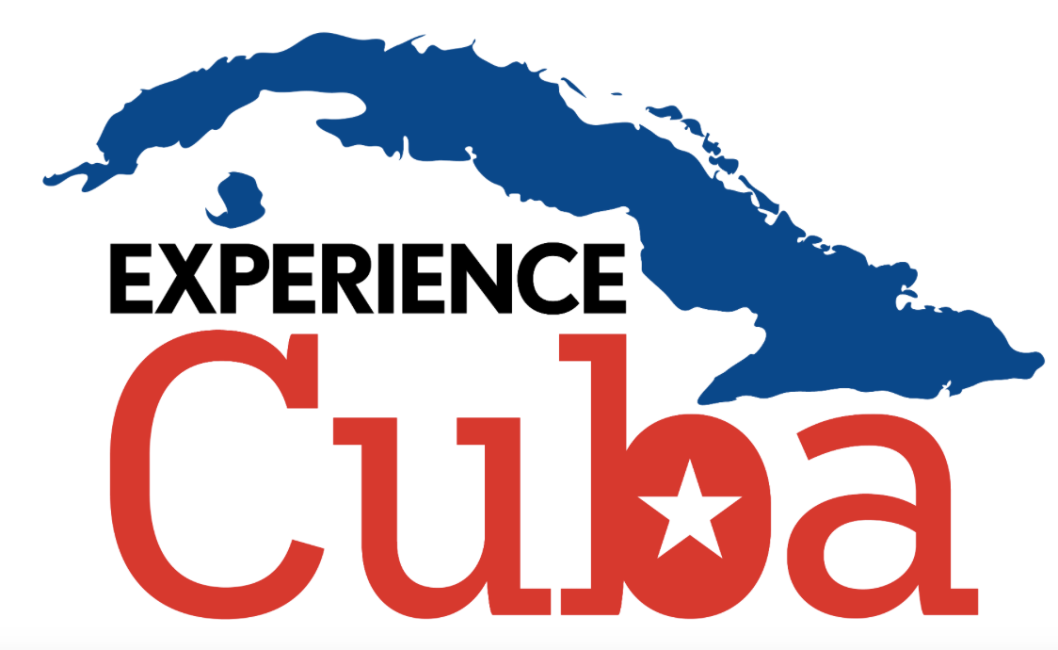
Updated November 5, 2018
Rotary Club January 13-18, 2019

*Itinerary is subject to change

Sunday January 13: Day 1 Havana (D)
- Arrival into Havana
- Graham Sowa and your local Cuban guide will greet you at Jose Marti International Airport
- Visit to Revolution Square, the epicenter of political and governmental buildings of the Cuban government, and it is the site where millions listened to speeches given by Fidel Castro.
- Check into Hotel Nacional
- Dinner in Habana 61, one of Havana’s best paladares

Monday January 14: Day 2 Havana (B,L)
- Visit to the Capitol building and enjoy a guided tour of this beautifully restored building.
- Walking tour of Old Havana with local expert guide, with stops specified to the interests of your group-artists workshops and galleries, thriving private enterprises, or architecture-to name a few options
- Visit with the founders of Clandestina, a successful private enterprise clothing shop in Old Havana. Learn more about entrepreneurial activities in Cuba and how this duo built their brand and business.
- Lunch at El Figaro restaurant, which donates part of its earnings to the successful Arte Corte community project
- Visit to Arte Corte salon, a successful community project that began with a barber shop that now has impacted the whole neighborhood.
- Free time in the afternoon to spend time in Old Havana. Wandering the
streets of Old Havana with a map in hand is truly the best way to explore this UNESCO World Heritage Site
- Dinner paid on own (group reservation name Bruce Stacy at 7pm at San Juan Bar and Grill in Old Havana, 7864-7422, 1061 San Juan De Dios Street)

Tuesday January 15: Day 3 Viñales (B,L)
- Depart after breakfast and enjoy a beautiful drive through the countryside to the western side of Cuba, to Piñar Del Rio, the tobacco capital of Cuba
- Drive to Pinar Del Rio, visit to Hector Luis Farm, one of the most well known tobacco farms in all of Cuba. Have a tour of the farm and interact with the family and workers, learning how tobacco is grown and cultivated
- Enjoy a countryside lunch on the farm complete with perhaps roasted pork, black beans, rice and yucca.
- After lunch you will drive back to Havana
- Dinner paid on your own (group reservation name Bruce Stacy at 8pm at Elizalde Restaurant at 521 Empedrado between Monserrate y Villegas, 7867-2157)

Wednesday January 16: Day 4 Havana (B,L,D)
- Take part in a volunteer project with Caritas organization
- Lunch in Mediterraneo farm-to-table restaurant in Vedado neighborhood
- **Cultural/volunteer project with Caritas organization**
- Visit to Rum Museum
- Free time to explore Havana on your own
- Dinner in San Cristobal Paladar

Thursday January 17: Day 5 Havana (B,L,D)
- This morning, take part in an interactive cooking class in Cojimar at a thriving private paladar. Enjoy a short tour of this small fishing village before touring a small neighbors farm and learning about farming in Cuba
- Get a hands on cooking class demonstration by getting into the kitchen and learning the ingredients of traditional cuban cuisine. Also, learn how to make a mojito from an expert bartender.
- Enjoy lunch at the paladar afterwards.
- Free time in the afternoon at the beach
- Dinner tonight at Grados restaurant in Vedado neighborhood with live music

Friday January 18: Day 6 Havana (B)
- After breakfast depart for your flight back to the States

Cost per person: $2,650/person
Single supplement: $600

Includes:
- Graham Sowa as tour leader to accompany group
- Experienced bilingual local guide
- Bottled water during trip
- Legal, licensed people-to-people tour requirements completed
- Meals outlined in the itinerary
- Accommodations outlined in the itinerary
- All entrance fees for activities in itinerary
- Air-conditioned transportation while in Cuba
- Airport transfers to/from Havana airport
- Tips included for local guide and driver

Not Included:
- Airfare to/from Cuba and tourist visa
- Travel and medical insurance
- Meals not specified in itinerary
- Items of personal nature-laundry, internet, alcohol etc.

